NOTES FROM CLIMATE CAFÉ LINKS

1. International Climate Café Model
https://www.climateandmind.org/climate-cafe

Introduction:
- Many people are concerned about climate issues
- People do not always talk about their concerns openly
- People feel alone with their thoughts and feelings
- Isolation exacerbates eco-anxiety, climate depression, and other responses to the climate crisis increase a sense of hopelessness, and confusion

Mission/Purpose/Philosophy/Goals

Foundational Principle/s:
- action on climate change will increase as more and more people, from a range of backgrounds, geographic locales, levels of political/environmental involvement, and walks of life, start to talk about Climate Change and discuss their questions, concerns, and hopes
- Cafes focus on accessibility and conversation first – not action planning etc
- The Climate Cafe model fills an additional, unmet need by providing a space for discussion to emerge, especially among those who are not necessarily already involved in climate action.

Goals
- Get more people together, in more places, talking about climate change in a supportive and welcoming space
- Flexibility to see what happens

More specific Purpose
- To bring together people within a local community
- To share a concern about human-induced climate change and hope for a better future for our planet
- To share a desire to discuss these hopes and concerns with others, and in the process gain and provide encouragement; support; and solidarity
- To share an interest in exploring how to take personal, community or global action to address climate change

Underlying principles:
- Human-induced climate change is real, and it is a problem: We’re not going to debate the scientific consensus.
- The café is welcoming and non-intimidating
- Climate Cafes should be approachable to people newly concerned about the issue, with limited knowledge, as well as those with a lot of experience or background in climate science or climate activism.
- Newcomers should not be made to feel intimidated or turned away due to lack of knowledge, activist experience, or carbon footprints.
- No one should feel guilted or lectured.
- Inclusivity: All are welcome, regardless of age, gender identity, sexual orientation, race, ethnicity, immigration-status, carbon-footprint, experience/knowledge about activism or climate change.

Local-empowerment:
- respect the distinct differences in communities, and want to empower communities to focus on topics and actions that the feel most passionate about.

Hope/Strength/Action-based:
- people should feel comfortable sharing grief, fear, despair, and sadness about climate change, environmental destruction, and the future of our species.
- to keep things in balance, include hope and action. If possible, participants should leave feeling empowered and energized, rather than hopeless and depressed.

Promotion/advertising:
- letterbox, schools, facebook, local neighbourhood sites, twitter, bulletin boards, postering
- create an information flyer (see link for details)

Group Structure/Process:
- Location: emphasize the “cafe” aspect (laid back, welcoming, cozy; not like going to a staff training event in a bland room with a white board), recommend starting off either at a local tea or
- Length of time: 90 minutes to start

Meeting structure:

Intro (15 min.)
- informal introductions, meet and greet; this should be informal, relaxing and non-intimidating for newcomers
Check in (30 min.)
- Check in about what people have been thinking about, feeling, worried about, and excited about.
- Group can either stay together, or chat in smaller groups.
- If there are enough people, split off by topic of interest (e.g., electric cars; local advocacy; grief or depression)
- It might be good for one or two people float around and get a sense of what people are talking about.
Action steps (30 min.)
- Focus on ideas for action. Again, can discuss as a group or break off.

Conclusion (10 min.)
- Closing comments, welcoming ideas for future meetings.
- It is highly recommended that facilitators focus on what people in the group are interested, rather than imposing their own idea on the group.

2. UK Extinction Rebellion Café
(YouTube video)
- set up to be a space where people can come and share their feelings about climate change and the ecological crisis
- a place where people listen to each other and to themselves
- to give people a space where they can share their feelings in a way that they might not be able to do in other parts of their lives
- begin each session with a name round and sharing something that has brought them there today
- being witness to self and others sharing feelings around climate change
- to be able to connect with others who share the same passions

3. Adelaide: Extinction Cafe – Meet and Greet

A facebook event offered last year:
Come and join us for a chat about Extinction Rebellion and the climate crisis. This is an informal get together to share our ideas, thoughts and feelings about climate issues and what it’s like to be living through the 6th mass extinction.

Directly before this event we will be presenting our Heading for Extinction talk. See more details here:
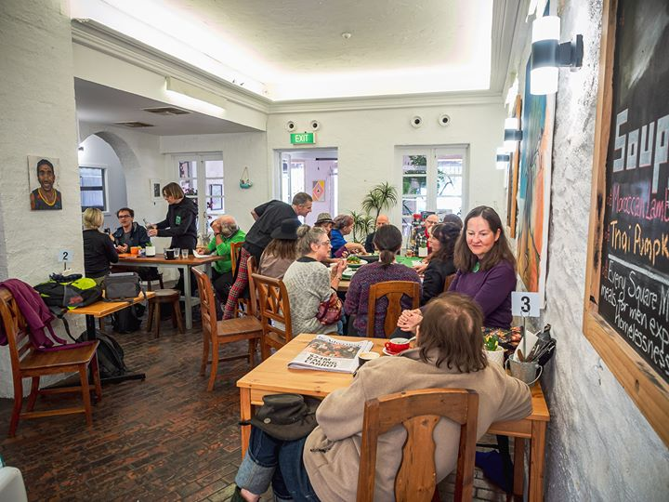
-----------------------------------

4. Thoughts and comments
- People are both curious and wary of XR – Q&R could be a way to attract people
- To begin, hold the café outside TSS in the garden, set up table with signage, free coffee and cake, merch, etc
- Separate H4X from the café – offer it at a different time and room (e.g. inside after the café)
- Offer both café and h4x at regular dates and times

